

**Western Australian Certificate of Education**

**ATAR course examination, 2017**

**Question/Answer Booklet**

12 PHYSICS

Name

**Test 8 – Modern Physics**

|  |  |  |  |  |  |  |  |  |  |  |
| --- | --- | --- | --- | --- | --- | --- | --- | --- | --- | --- |
| Student Number: In figures |  |  |  |  |  |  |  |  |  |  |

**Mark: $\frac{}{\text{48}}$**  In words

#### Time allowed for this paper

Reading time before commencing work: five minutes

Working time for paper: sixty minutes

**Materials required/recommended for this paper**

To be provided by the supervisor

This Question/Answer Booklet

Formulae and Data Booklet

***To be provided by the candidate***

Standard items: pens, (blue/black preferred), pencils (including coloured), sharpener, correction fluid/tape, eraser, ruler, highlighters

Special items: non-programmable calculators satisfying the conditions set by the School Curriculum and Standards Authority for this course

**Important note to candidates**

No other items may be taken into the examination room. It is your responsibility to ensure that you do not have any unauthorised notes or other items of a non-personal nature in the examination room. If you have any unauthorised material with you, hand it to the supervisor before reading any further.

**Structure of this paper**

|  |  |  |  |  |  |
| --- | --- | --- | --- | --- | --- |
| Section | Number of questions available | Number of questions to be answered | Suggested working time  (minutes) | Marks available | Percentage of exam |
| Section One:  Short Answers | - | - | - | - | - |
| Section Two:  Problem-solving | 10 | 10 | 60 | 50 | 100 |
| Section Three:  Comprehension | - | - | - | - | - |
|  |  |  |  | **Total** | 100 |

**Instructions to candidates**

1. The rules for the conduct of examinations at Holy Cross College are detailed in the College Examination Policy*.* Sitting this examination implies that you agree to abide by these rules.

2. Write your answers in this Question/Answer Booklet.

3. Working or reasoning should be clearly shown when calculating or estimating answers.

4. You must be careful to confine your responses to the specific questions asked and to follow any instructions that are specific to a particular question.

5. Spare pages are included at the end of this booklet. They can be used for planning your

responses and/or as additional space if required to continue an answer.

• Planning: If you use the spare pages for planning, indicate this clearly at the top of the page.

• Continuing an answer: If you need to use the space to continue an answer, indicate in the original answer space where the answer is continued, i.e. give the page number. Fill in the number of the question(is) that you are continuing to answer at the top of the page.

6. Answers to questions involving calculations should be ***evaluated and given in decimal***

***form*.** It is suggested that you quote all answers to ***three significant figures***, with the

exception of questions for which estimates are required. Despite an incorrect final result, credit may be obtained for method and working, providing these are ***clearly and legibly set out***.

7. Questions containing the instruction "estimate" may give insufficient numerical data for their solution. Students should provide appropriate figures to enable an approximate solution to be obtained. Give final answers to a maximum of two significant figures and include appropriate units where applicable.

8. Note that when an answer is a vector quantity, it must be given with magnitude and direction.

9. In all calculations, units must be consistent throughout your working.

**Additional Data**

**Fundamental particles**

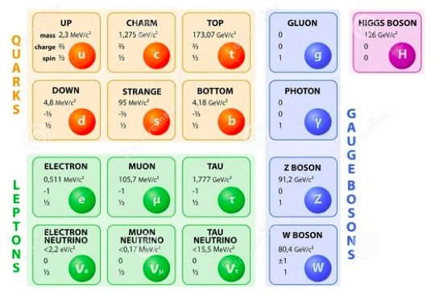

Table of common mesons

|  |  |  |
| --- | --- | --- |
|  |  |  |

|  |
| --- |
|  |
|  |
|  |

**Common Baryons**

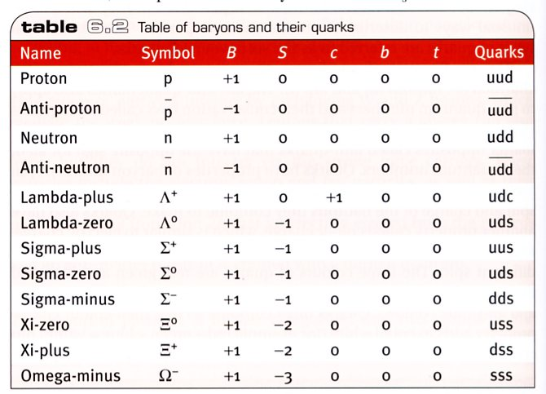

**Common Mesons**

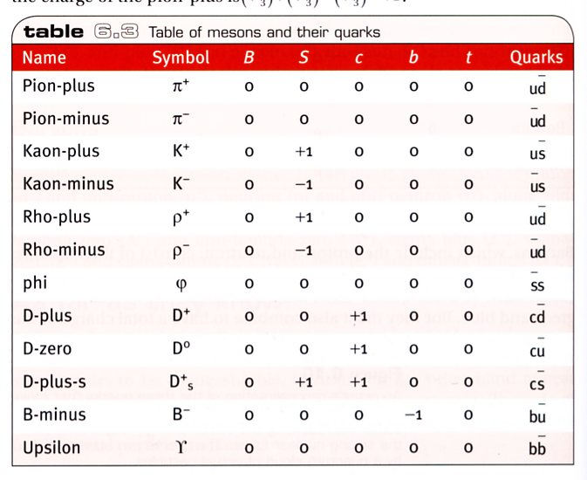

**Redshift and recessional velocity**



It can also be shown that:

where: z = redshift

Δλ = change in wavelength (moving source) (nm)

λ = wavelength of stationary source (nm)

v = recessional speed of galaxy (ms-1)

c0 = speed of light in a vacuum (ms-1)

**Hubble’s Law**



where vgalaxy = recessional speed of galaxy (kms-1)

d = distance to galaxy (Mpc)

Ho = Hubble’s constant (kms-1Mpc-1)

1.00 pc = 3.26 light years

1. A spacecraft moving at 95.0 % of the speed of light passes the Earth on a journey to the star Lalande-21185, a distance of 8.29 light years.

***In the frame of reference of the spacecraft (experienced by the crew),*** what time and spatial measurements of the journey are different compared to those measured by an

Earth -based observer? Which ***TWO*** statements are correct? [2 marks]

(a) Length contraction states, ‘the path length through space is longer than 8.29 light years’.

(b) Length contraction states, ‘the path length through space is shorter than 8.29 light years’.

(c) Time dilation states, ‘the clock on earth is moving slower’.

(d) Time dilation states, ‘the clock on the spacecraft is moving slower’.

In the frame of reference of the Earth, what time and spatial measurements of the journey are different compared to those measured by an observer on the spacecraft? Which ***TWO*** statements are correct? [2 marks]

(a) Length contraction states, ‘the path length through space is shorter than 8.29 light years’.

(b) Length contraction states, ‘the path length through space will be 8.29 light years’.

(c) Time dilation states, ‘the clock on earth is moving slower’.

(d) Time dilation states, ‘the clock on the spacecraft is moving slower’.

2. Explain what is meant by the term, ***‘inertial reference frame’***. [1 mark]

3. State the two postulates of Einstein's theory of Special Relativity. [2 marks]

•

•

4. Two spaceships are moving away from a star and travelling in the same direction. Spaceship A is travelling at 0.950 c while spaceship B is moving at 0.700 c.

(a) What would an observer on spaceship A determine to be the speed of the starlight passing by? Explain your answer. [3 marks]

(b) According to an observer on Starship B, what is the speed of starship A? [3 marks]

5. Consider the proposed new Sydney to Perth bullet train that travels at a speed of 0.365 c. A passenger on the bullet train measures the dimensions of the carriage she is in as 3.50 m high and 25.0 m long.

As the train passes through a level crossing, a stationary observer notices the dimensions of the carriage. What would be the dimensions measured by this observer? [6 marks]

6. One of the biggest accelerators in the world is at CERN in Geneva, the site of the Large Electron-Positron (LEP) collider. It is 27.0 km long and accelerates charged particles to enormous energies in the 50.0 GeV energy range.

(a) Calculate the relativistic mass of a proton travelling along the particle accelerator with a speed of 0.915 c [4 marks]

(b) What is the ***total energy*** of a proton travelling along the particle accelerator with a speed of 0.915 c? [6 marks]

(c) Will the proton ever be able to reach the speed of light? Explain your answer.

[3 marks]

7. One of the most intense sources known to radio astronomers is the Galaxy NGC5128. Long exposure photographs show it to be a giant elliptical galaxy crossed by a band of dark. It lies about 1.50 x 107 light years away from earth. Using a value of the Hubble constant of

73.0 kms-1Mpc-1, calculate the recessional velocity of NGC5128. [4 marks]

8. The K-line of light from singly ionised calcium has a wavelength of 393.3 nm when measured in a laboratory. The same line in the spectrum of galaxy NGC 4889 has a wavelength of 401.8 nm. Calculate the recessional velocity of NGC4889. [4 marks]

9. Consider the Feynman diagrams shown below. Identify the fundamental force described in each diagram. Write your answer in the space provided below the diagram.

[4 marks]

|  |  |  |
| --- | --- | --- |
|  |  |  |
| a) | b) |  |
|  |  |  |
| c) | d) |  |

10. Determine which of the following reactions are forbidden. Explain your answer.

(a) p+ + p- 🡪 μ+ + e- [2 marks]

(b) p+ + p+ 🡪 p+ + π+ [2 marks]

(c) π- + p+ 🡪 p+ + π+ [2 marks]